AUDITIONS
Woodland Theatre Presents
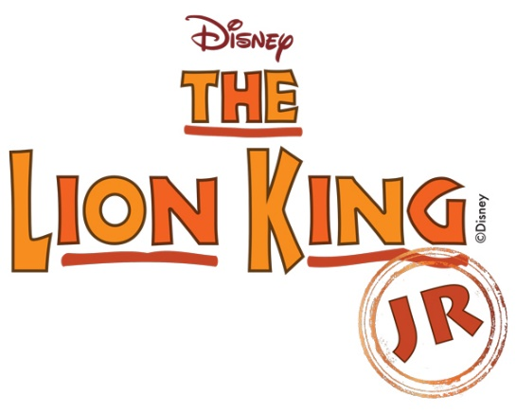
Saturday June 24, 2017
10:00 MANDATORY
Parent/Guardian Meeting
11:00 Auditions Begin
12:30 Lunch Break
1:00 Auditions Resume Until Finished
Sunday June 25, 2017
10:00 Call Back Auditions
Auditions and Performances will be held at the
Woodland Theatre
120 W 3rd Ave, Kettle Falls, WA 99141
Directed/Producer
Linette Richie
Performance Dates:
August 11, 12, 13, 18, 19, 20
Music & Lyrics by
Elton John & Tim Rice
Additional Music & Lyrics by
Lebo M, Mark Mancina, Jay Rifkin, &
Hans Zimmer
Based on the Broadway production directed by
Julie Taymor
For more information, visit our website http://www.woodlandproductions.org
This is NOT a School-Sponsored Event
Disney’s The Lion King JR. is presented through special arrangement with and all authorized materials are supplied
By Music Theatre International. 421 West 54th Street, New York, NY 10019
Script, music, and all other material © 2015 Disney Broadway Junior and MTI’s Broadway Junior Collection are trademarks of
Music Theatre International.
All rights reserved.
Audition Information:
- Auditions are open to children 6 to 16 years of age. A wide variety of stage roles for males & females are available.
- A wide variety of non-acting & non-singing roles are available: make-up, props, costuming, technical, stage managers, & other support positions available for children 6 to 16 years of age.
- All children auditioning for a lead part must be prepared to perform the audition song for that character.
- All of the rehearsal music can be found at: https://www.youtube.com/watch?v=ET8WA9rlEIU&list=PLLb1A1sS2On9zLgW9Drfbo4s6jMSHQqiY
- No microphones will be used; performers must project their voices loud enough to be heard throughout the theatre.
- Show’s audition includes movement & dance. Please wear appropriate clothes & shoes to move in.
- Parent/Guardian must be at the mandatory meeting Saturday June 24, 2017 at 10:00 AM to fill out child’s information; sign consent forms, & have dates available that may conflict with the show’s rehearsal dates & performance schedule.

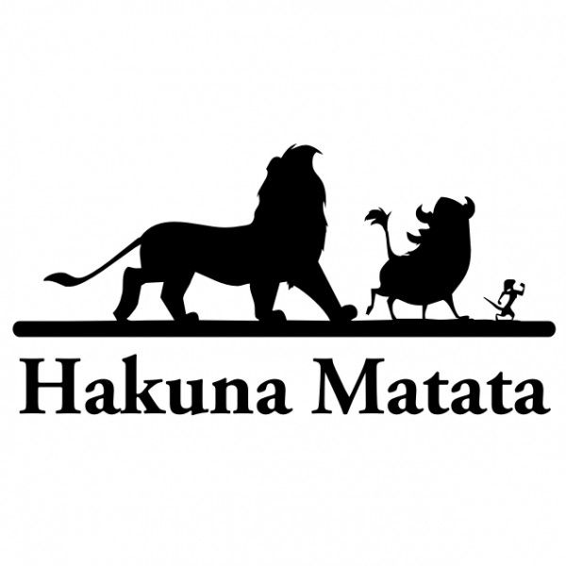

The Lion King, Jr. Character List

Rafiki (Mid to older age boy or girl): Must audition with own prepared song. Rafiki has significant solos in "Circle of Life" and "He Lives in You," and leads the African chants throughout the show, so this must be a confident performer with a strong singing voice.
Mufasa (Older Boy): Must audition with own prepared song. Older Male Performer must be able to perform a strong, honorable, and wise lion who commands respect onstage and also able to show tenderness with his son, Simba.
Scar (Mid to older Boy): Must audition with own prepared song. This character has a sarcastic sense of humor and is a villain with a dark side.
Young Simba (Younger Boy): Must audition with own prepared song. Must be a strong singer and dynamic performer. Simba is playful, energetic, and naive, but after his father Mufasa's death, Simba struggles with shame and his destiny.
Adult Simba (Older Boy): Must audition with own prepared song. Must be a mature actor with strong singing voice. Older Simba has moments that are more complex as he reunites with Nala, mourns his father, and returns to confront Scar.
Young Nala: (Young Girl) Must be a strong singer and actress. A courageous lion and young Simba's best friend. She is not afraid to speak her mind.
Adult Nala (Older Girl) Must audition with own prepared song. Must be a mature actress with strong singing voice. Grows from a cub to a lioness before she confronts Scar.
Sarafina (Older Girl) Must be a mature actress with strong voice. A featured lioness and Nala's mother.
Sarabi (Older Girl): Mufasa's mate, and Simba's mother. Sarabi has speaking lines. She must deliver the care and command of a queen.
Zazu (Any Age Boy or Girl): This character is an anxious yet loyal assistant to Mufasa who is always busy trying to do his duty.
Banzai (Any Age boy or girl): Must be an outgoing and confident actor who can portray nastiness and gruffness. A slick yet childish hyena who works for Scar. He would be the leader of the group if hyenas were not so lazy.
Shenzi (Any Age boy or girl): Must be able to be the sassy one of the trio and able to laugh loudly and long, as well as be menacing to Young Simba and Young Nala.
Ed (Any Age boy or girl): Actor must laugh unabashedly and communicate through physicality and facial expressions rather than words. The third member of Scar's trio of lackeys. Character has a loud, cackling laugh that is the only form of communication.
Scar's Hyena Army (All Ages boys & girls): These hyenas can double, as animals of the Pridelands or lionesses. Hyenas are mangy, mindless creatures who sing in "Be Prepared."
Timon (Medium age to older age boy or girl): Must audition with own prepared song. Must be charismatic actor or actress who understands comic timing. An outcast meerkat who lives in the jungle with Pumbaa. He is afraid of his own shadow, but pretends to be the confident, relaxed leader of the duo.
Timon (Medium age to older age boy or girl): Must audition with own prepared song. Must be able to portray this loveable and loyal friend to Timon and Simba with deadpan humor.
Ensemble (All Ages boys & girls): The ensemble plays various inhabitants of the Pridelands, such as giraffes, elephants, antelopes, wildebeest, and other creatures in the play.
Lionesses (Any age girls) Must be strong singers and dancers. This group is highlighted in, "The Lioness Hunt," "The Mourning," and "Shadowland."
During the audition, the music will have no voice with the music.
Audition songs can be found at: https://www.youtube.com/watch?v=ET8WA9rlEIU&list=PLLb1A1sS2On9zLgW9Drfbo4s6jMSHQqiY

Audition song for Zazu, Young Simba, Young Nala, and ensemble  I Just Can’t Wait to be King  Zazu: Spoken- Simba?...Nala? Where are you hiding?!?! If you don’t come out this instant – This isn’t funny. I’m not laughing.  Simba: I'm gonna be a mighty king. So enemies beware!  Zazu: I've never seen a king of beasts, With quite so little hair  Simba: I'm gonna be the mane event. Like no king was before.  I'm brushing up on looking down. I'm working on my ROAR!  Zazu: Thus far, a rather uninspiring thing  Simba: Oh, I just can't wait to be king!  Zazu: (Speaking)] You've rather a long way to go,  young master, if you think...  Simba: No one saying do this  Zazu: when I said that, I--  Simba: No one saying be there  Zazu: What I meant was...  Simba: No one saying stop that  Zazu: what you don't realize...  Simba: No one saying see here  Zazu: Now see here!  Simba: Free to run around all day  Zazu: Well, that's definitely out...  Simba: Free to do it all my way!  Audition song for Scar & Hyenas  Be Prepared  Parts are marked for when you are to sing  (Scar) Spoken- I never thought hyenas essential; you’re crud and unspeakably plain. But maybe you’ve a glimmer of potential if aligned with my vision and brain.  (Hyenas) Hem, hem, hem, hem  (Scar) I know that your powers of retention are as wet as a warthog's backside. But thick as you are, pay attention! My words are a matter of pride.  It's clear from your vacant expressions the lights are not all on upstairs. But we're talking kings and successions; even you can't be caught unawares!  (Hyenas) Oooo ha ha ha. Ooooo ha ha ha. Ha ha ha—ha ha ha hah!  (Scar & Hyenas) Let’s prepare for a chance of a lifetime. Be prepared for sensational news. A shining new era is tiptoeing nearer.  (Hyenas) And where do we feature?  (Scar) Just listen to teacher! I know it sounds sordid but you'll be rewarded when at last I am given my dues and injustice deliciously squared. Be prepared!  (Hyenas)When Scar starts @ “know”--- Hah hah hah hah hah hah hah hah hah hah hah hah hah hah hah hah hah hah hah hah hah! Be prepared!  Audition song for Pumba & Timon  Hakuna Matata  Parts are marked for when you are to sing  (Timon) Hakuna Matata! What a wonderful phrase  (Pumbaa) Hakuna Matata! Ain't no passing craze  (Timon) It means no worries for the rest of your days  (Both) It's our problem-free philosophy  (Timon) Hakuna Matata!  (Young Simba) Hakuna Matata?  (Pumbaa) Yeah. It's our motto!  (Young Simba) What's a motto?  (Timon) Nothing. What's a-motto with you?  (Pumbaa) Hakuna Matata Those two words will solve all your problems  (Timon) That's right. Take Pumbaa here…Why, when he was a young warthog...  (Pumbaa) When I was a young wart hog  (Timon)Very nice  (Pumbaa) Thanks  (Timon) He found his aroma lacked a certain appeal. He could clear the savannah after every meal.  (Pumbaa) I'm a sensitive soul though I seem thick-skinned. And it hurt that my friends never stood downwind. And oh, the shame…. (Timon)He was ashamed  (Pumbaa) Thought of changin' my name (Timon) What's in a name?  (Pumbaa) And I got downhearted (Timon) How did ya feel?  (Pumbaa) Everytime that I...  (Timon) Hey! Pumbaa! Not in front of the kids!  (Simbaa) Oh. Sorry! | Audition song for Young Rafiki  The Circle of Life  If auditioning for Rafiki, you will audition with this part of “Circle of Life”. Only sing part marked as Rafiki.  Rafiki: Nan____ts’in-go-nya-ma, ba-ki-thi, baba.  (Ensemble) Si-thi hu. ‘Ngo-nya-ma. Si-thi hu. ‘Ngo-nya-ma.  Rafiki: Nan____ts’in-go-nya-ma, ba-ki-thi, baba. (Ensemble) Si-thi hu. ‘Ngo-nya-ma.  Rafiki: He-le-le! (Ensemble) ‘Ngo-nya-ma.  Rafiki: Si-zo-nqo’! (Ensemble) ‘Ngo-nya-ma Rafiki: He-le-le!  (Ensemble) ‘Ngo-nya-ma. ‘Ngo-nya-ma.  Rafiki: I-ngo-nya-ma neng-we ‘na-ma-ba-la I-ngo-nya-ma neng-we ‘na-ma-ba-la I-ngo-nya-ma neng-we ‘na-ma-ba-la I-ngo-nya-ma neng-we ‘na-ma-ba-la From the day we arrive on the planet. And blinking, step into the sun. There is more to see than can ever be seen, more to do than can ever be done. There is far too much to take in here. More to find than can ever be found. but the sun rolling high, through the sapphire sky. Keeps great and small on the endless round. It's the Circle of Life and it moves us all. Through despair and hope. Through faith and love. ‘Til we find our place. On the path unwinding. In the Circle, The Circle of Life.  Audition song for Mufasa  They Live in You  If auditioning for Mufasa, you will audition with this part of “They Live in You”. Do not sing ensemble part, only these words are Mufasa:  Night-- and the spirit of life calling, ma-me-la.  And a voice with the fear of a child asking, oh ma-me-la.  SPOKEN: Simba, let me tell you something my father told me. Look at the stars. The great kings of the past look down on us from those stars.  Wait, there's no mountain too great. Hear these words and have faith. Oh oh oh---have faith.  SPOKEN: So whenever you feel alone, just remember that those kings will always be there to guide you. And so will I.  They live in you. They live in me. They're watching o-ver everything we see.  In every creature. In every star. In your reflection, they live in you.  Audition song for Sarafina, Sarabi, & Lionesses  Lioness Hunt  (ALL)Ah ha hayi—(ya) hayi (ya) hayi—(ya) hayi. Wey ba-ba zin-ge-la, si-yo zin-ge-la, ba-ba. (repeat)  Wey ba-ba. Zin-ge-la, si-yo, zin-ge-la ba-ba  (Repeat)  Hi ba-ba. S’qhu-be-ke-ni si-yo zin-ge-la  Hem Hem Hem Hem Hem Hem Hem Hem Hem Hem Hem Hem Hem Hem!  Ah ha hayi—(ya) hayi (ya) hayi—(ya) hayi. We ba-ba zin-ge-la, si-yo zin-ge-la, ba-ba  Music & Lyrics by, Elton John & Tim Rice Additional Music & Lyrics by, Lebo M, Mark Mancina, Jay Rifkin, & Hans Zimmer  Disney’s The Lion King JR. is presented through special arrangement with and all authorized materials are supplied  By Music Theatre International. 421 West 54th Street, New York, NY 10019  Script, music, and all other material © 2015 Disney Broadway Junior and MTI’s Broadway Junior Collection are trademarks of  Music Theatre International.  All rights reserved.

